**Muhammad Abdullah**

**I22-1721**

**COMPUTER NETWORKS**

**SEMESTER PROJECT**

**CISCO PACKET TRACER**

Overview:

This project involved designing and setting up a complex network topology. Various subnetting methods and routing protocols were implemented to meet specific host and network needs. The primary emphasis was on utilizing Variable Length Subnet Masking (VLSM) to efficiently allocate IP addresses across multiple networks, ensuring optimal utilization of the available address space.

The work also included configuring multiple servers, setting up routing protocols, and implementing features like Access Control Lists (ACL) and Network Address Translation (NAT).

Details:

* IP CONFIGURATION

This is IP configured on one router  
Similarly all routers are given IP’s on multiple interfaces according to VLSM

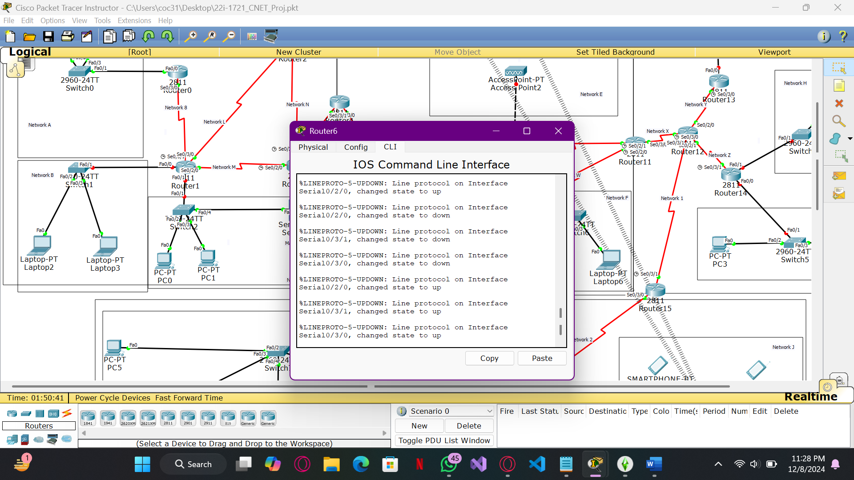

* ROUTING
* The next step involved configuring routing protocols tailored to the defined network areas, including RIP, OSPF, and EIGRP. Each routing method was set up according to its specific requirements and functionality to ensure seamless communication across the network. Below are screenshots demonstrating the configuration of a router for each routing protocol.

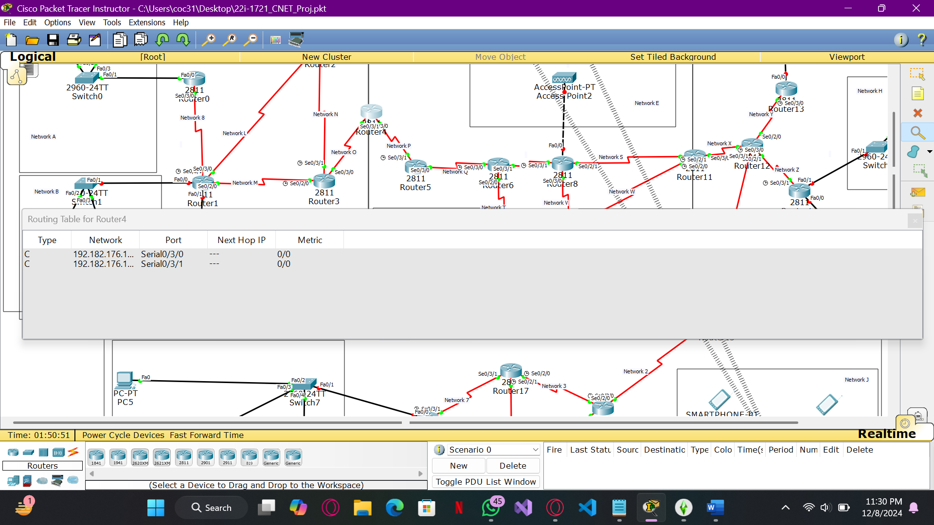

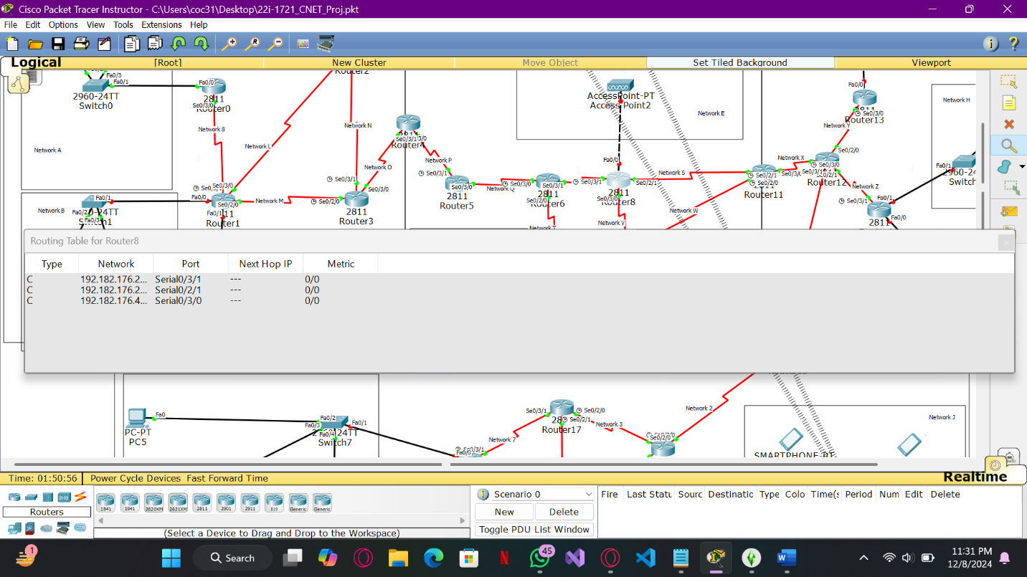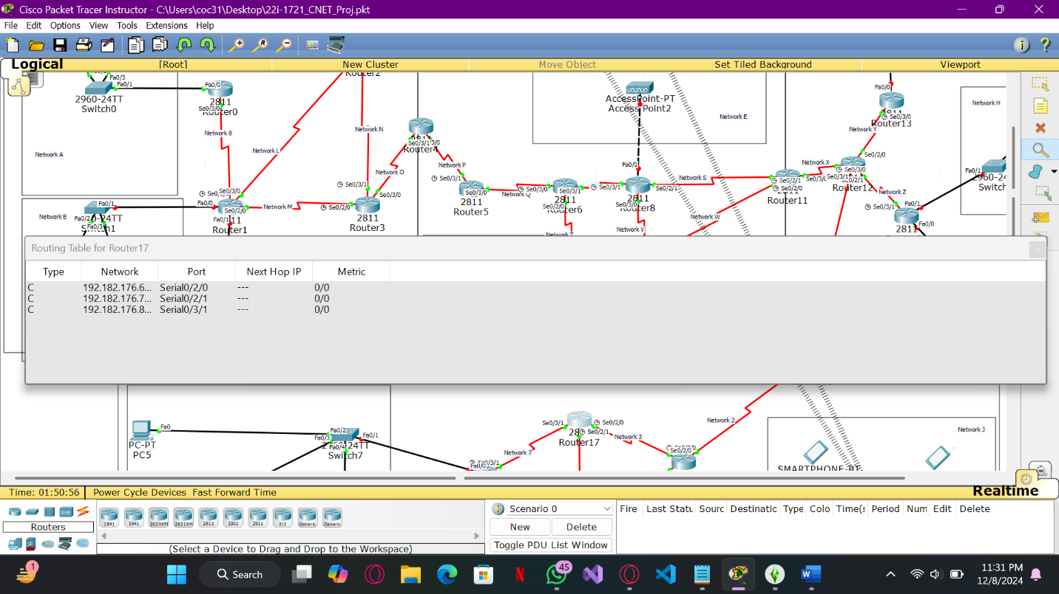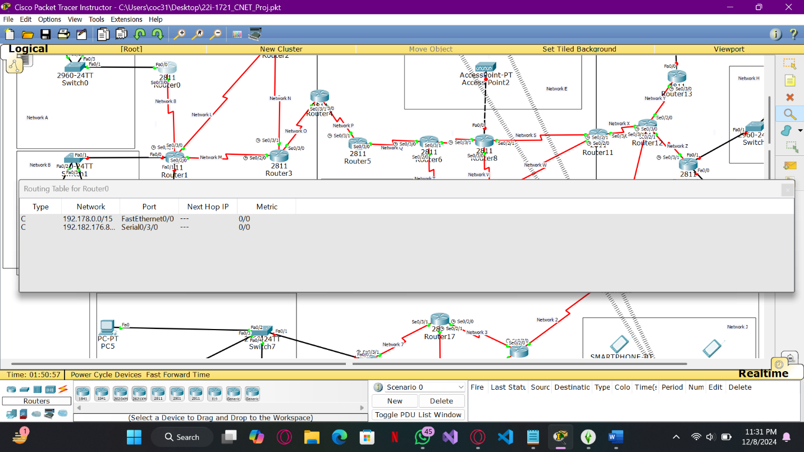

* REDISTRIBUTION
* The next step involved implementing route redistribution between different routing areas. RIP-to-OSPF redistribution was configured on one router, while OSPF-to-EIGRP redistribution was carried out on two routers. Below is a screenshot of the routing tables from the routers where redistribution was performed, showcasing the integration of routes from multiple protocols.

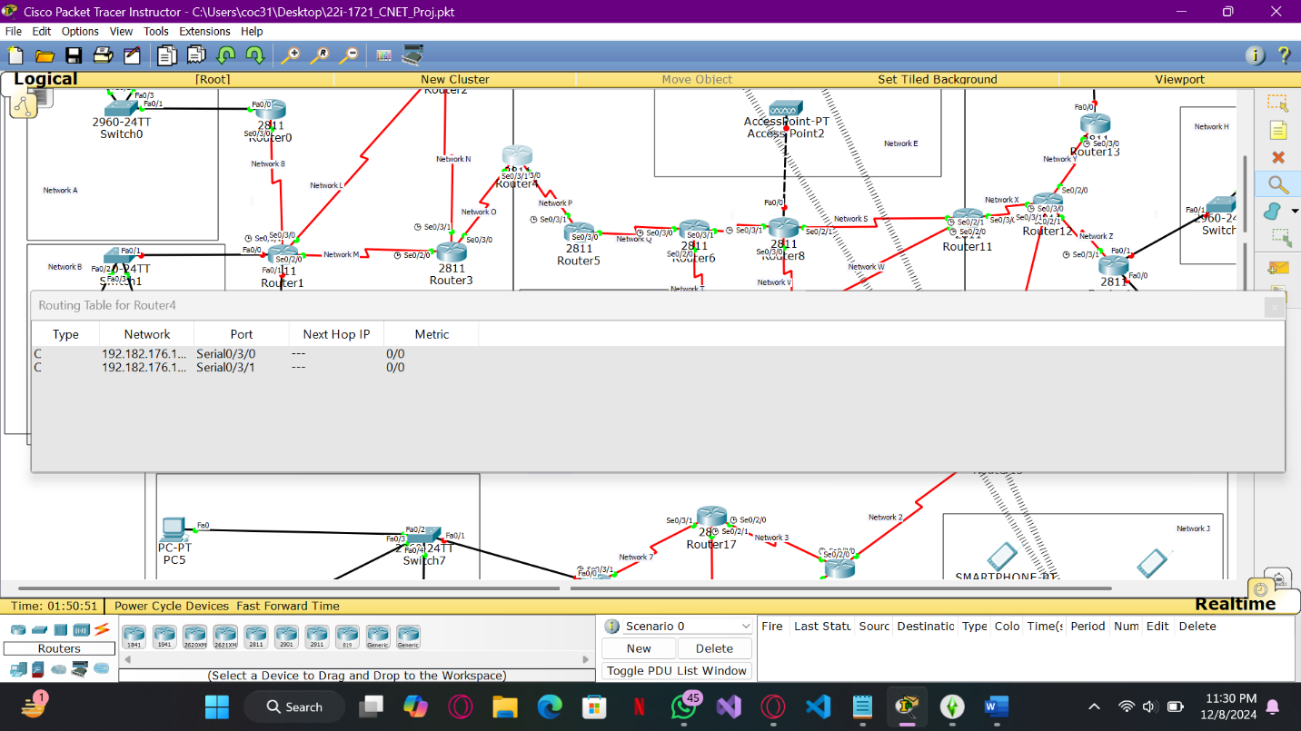

Successful packet transfer between routers having different routing techniques:

* DHCP
* All networks were configured on the DHCP server, including their corresponding subnet masks and DNS server settings (used for the mail server). Below is a demonstration of the DHCP IP configuration on an end device, showcasing the automated assignment of IP addresses and other network settings.

SERVER:

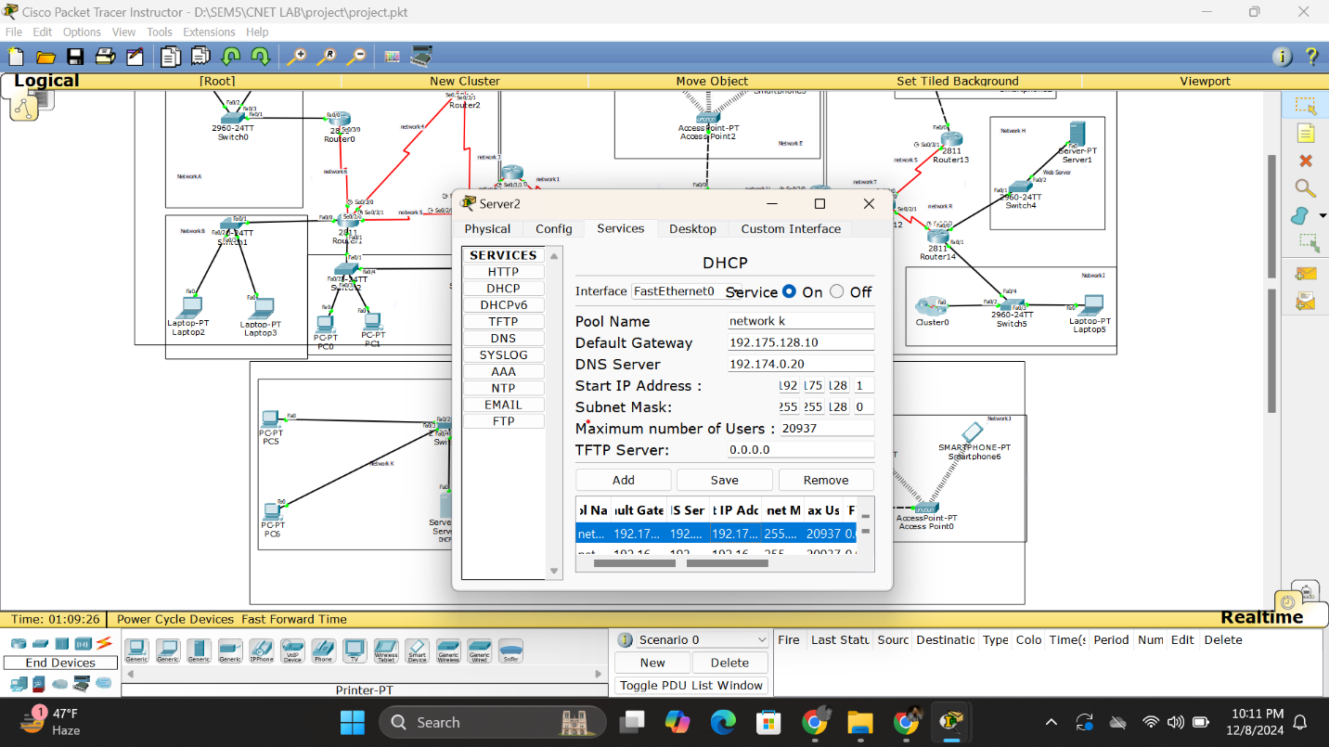

* SMTP

Mail transfer functionality was enabled across the network, allowing seamless communication between any end device within the topology. This was achieved by properly configuring the mail server and ensuring all necessary network protocols were in place.

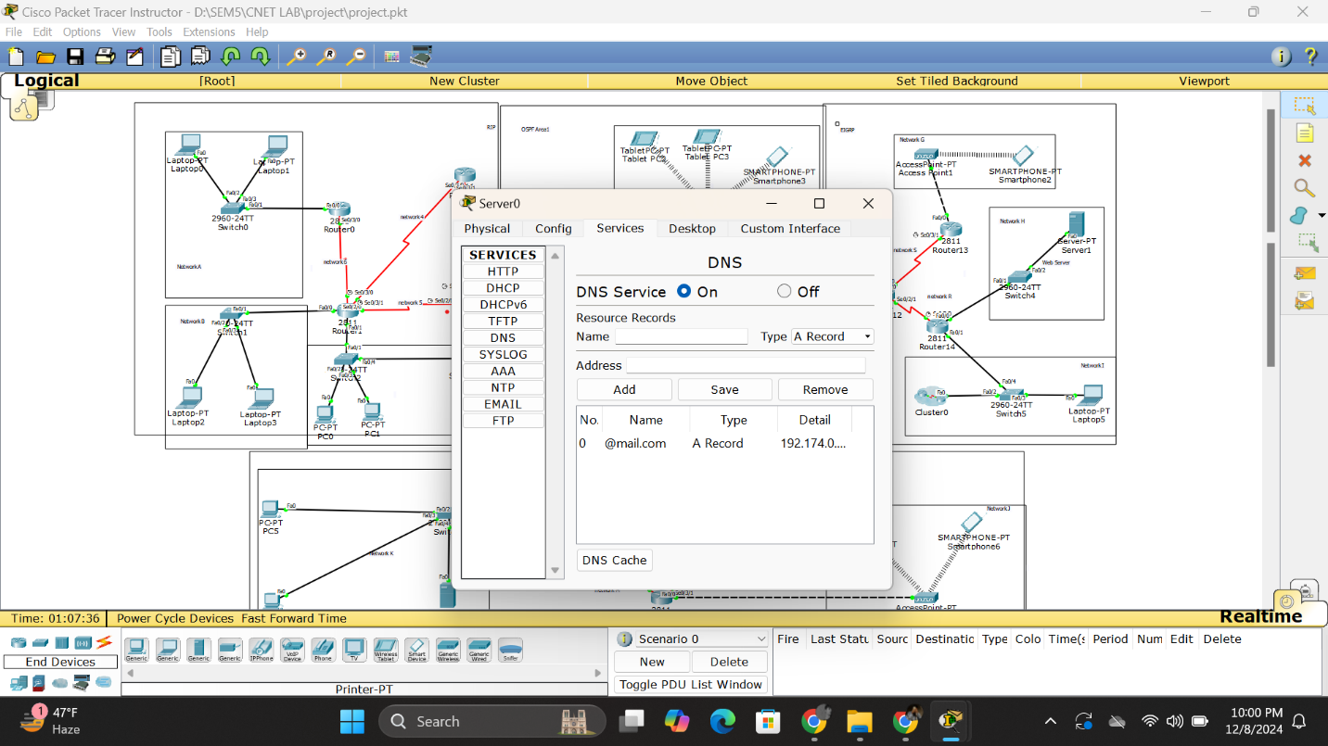

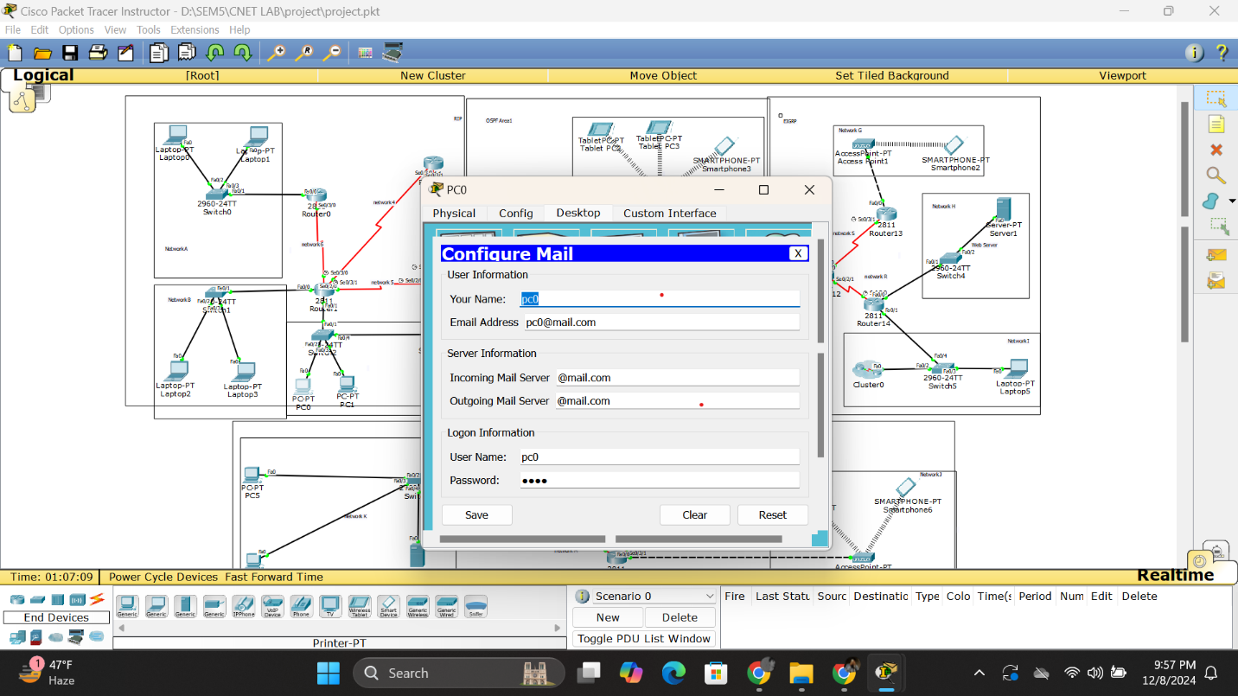

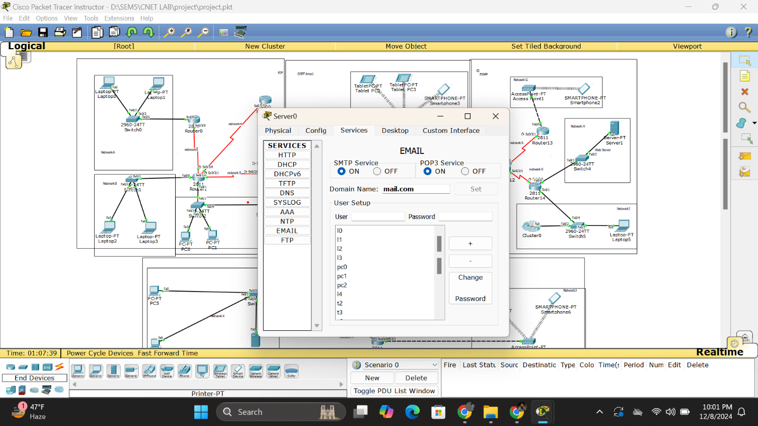

* ACL

Access Control Lists (ACLs) were implemented to restrict specific traffic within the network. Web browsing was blocked for designated devices and for all devices within the D network, ensuring controlled access based on defined policies.

